CHAPTER 1
INTRODUCTION
1.1 ORGANIZATION PROFILE
KNS Vegetable & Fruit Store is a local retail store that specializes in selling fresh vegetables and fruits to customers. The shop was established nearly 10 years ago with the aim of providing fresh, healthy, and quality agricultural products to the local community at affordable prices. Over the years, the store has built a strong reputation for its reliable service, quality produce, and customer-friendly approach.
The store sources vegetables and fruits from nearby farmers and wholesale markets to ensure freshness and availability. By maintaining good relationships with farmers and suppliers, the shop is able to provide seasonal fruits and vegetables to customers regularly. The store focuses on maintaining quality standards and proper storage to keep the products fresh for customers.
KNS Vegetable & Fruit Store serves a wide range of customers including households, small businesses, and local vendors. Customers visit the shop to purchase fresh produce daily, and the store ensures that products are stocked according to demand. The organization aims to promote healthy eating by providing fresh agricultural products to the community.
The shop is managed by the store owner, who oversees purchasing, inventory management, and customer service. With its commitment to quality and service, KNS Vegetable & Fruit Store has successfully operated for a decade and continues to serve customers efficiently.

1.2 System specification
1.2.1 HARDWARE SPECIFICATION
Processor: AMD Ryzen Series Processor – Multi-core processor.
Memory (RAM): 8 GB DDR4 RAM
Keyboard: Standard Full-Size Backlit Keyboard
1.2.2 SOFTWARE SPECIFICATION
Operating System: Windows 11
Frontend: HTML, CSS, JavaScript, Bootstrap, python (flask)
Backend: MySQL

1.2.3 SOFTWARE DESCRIPTION
FRONT END
HTML
HTML is used for creating and structuring the web pages of the Harvest Hub platform. It defines the layout and organization of the content such as text, images, tables, forms, and buttons. It forms the backbone of the website, providing the foundation upon which all design and functionality are built.
Features:
Supports multimedia elements like <audio> and <video> without external plugins.
Enhanced form controls such as date pickers and input validation.
Improved semantic elements like <header>, <footer>, <article>, and <section> for better readability and SEO.
Cross-platform compatibility, ensuring smooth rendering on various devices
CSS (Cascading Style Sheets)
CSS3 is used to design and style the Harvest Hub web pages. It enhances the visual appearance of the website by defining layout, colors, fonts, and spacing.
Features:
Supports advanced styling features such as gradients, transitions, and animations.
Enables responsive design using media queries for mobile and desktop compatibility.
Allows external stylesheets to maintain consistency across all pages.
Provides flexible layout models like Flexbox and Grid for structured page design.

3. JavaScript
Usage: JavaScript is used to make the Harvest Hub platform interactive and dynamic. It allows real-time updates without reloading pages and enhances the usability of forms and dashboards.
Features:
Provides event-driven programming for responsive user interaction.
Supports DOM (Document Object Model) manipulation for dynamic content updates.
Integrates easily with HTML and CSS for complete front-end functionality.
Enables asynchronous operations using AJAX for smooth data communication.
4. Bootstrap Framework
Bootstrap is used to develop responsive and mobile-friendly web pages for the Harvest Hub system. It provides pre-styled components and a flexible grid system.
Features:
Responsive grid layout for automatic adjustment across screen sizes.
Predefined CSS and JS components like modals, buttons, navigation bars, and alerts.
Cross-browser compatibility ensuring consistent look and feel.
Built-in support for icons and typography customization.

PYTHON
Python is a widely used general-purpose, high level programming language. It was initially designed by Guido van Rossum in 1991 and developed by the Python Software Foundation. It was mainly developed for emphasis on code readability, and its syntax allows programmers to express concepts in fewer lines of code.
Python is a high-level, interpreted, interactive, and object-oriented scripting language. Python is designed to be highly readable. It uses English keywords frequently whereas other languages use punctuation, and it has fewer syntactical constructions than other languages.
Python is Interpreted: Python is processed at runtime by the interpreter. You do not need to compile your program before executing it.
Python is Interactive: You can actually sit at a Python prompt and interact with the interpreter directly to write your programs.
Python is Object-Oriented: Python supports object-oriented style or technique of programming that encapsulates code within objects.
Python is a Beginner’s Language: Python is a great language for beginner-level programmers and supports the development of a wide range of applications — from simple text processing to WWW browsers to games.
PYTHON FEATURES
Easy to Learn: Python has few keywords, simple structure, and a clearly defined syntax. This allows students to pick up the language quickly.
Easy to Read: Python code is more clearly defined and visible to the eyes.
Easy to Maintain: Python’s source code is fairly easy to maintain.
Broad Standard Library: Python’s library is very portable and cross-platform compatible on UNIX, Windows, and Macintosh.
- Extendable: You can add low-level modules to the Python interpreter. These modules enable programmers to add to or customize their tools to be more efficient.
- Databases: Python provides interfaces to all major commercial databases.
- GUI Programming: Python supports GUI applications that can be created and ported to many system calls, libraries, and window systems, such as Windows MFC, Macintosh, and the X Window system of Unix.
- Scalable: Python provides a better structure and support for large programs than shell scripting.
- Easy to Learn and Read: Python has a simple and clean syntax, making it beginner-friendly and easy to understand.
- Interpreted Language: Python is interpreted, meaning the code is executed line by line, which makes it easier to test and debug.
- Dynamically Typed: Variables in Python do not require explicit declaration of data types. The type is assigned dynamically during execution.
- Object-Oriented: Python supports object-oriented programming (OOP) concepts, including classes, inheritance, polymorphism, and encapsulation.
- Extensive Standard Library: Python has a large standard library with modules and packages that can be used for tasks such as file handling, web development, and data manipulation.
- Cross-Platform: Python is available on various platforms like Windows, macOS, and Linux, which makes it portable across different operating systems.
Back End
MySQL
Introduction
MySQL is an open-source Relational Database Management System (RDBMS) that uses Structured Query Language (SQL) for storing, retrieving, and managing data efficiently. It was originally developed by MySQL AB and is now maintained by Oracle Corporation. MySQL is one of the most popular and reliable databases used in web-based applications due to its speed, scalability, and ease of use.
In the Harvest Hub project, MySQL is used to store all essential data such as user details, product information, transaction records, and communication logs between farmers and buyers. It serves as the backend database for the Flask-based web application.

Features of MySQL
Open-source database system
High performance and fast processing
Relational database (tables with rows and columns)
Multi-user access support
Strong security and user authentication
Data integrity using keys and constraints
Scalable for small and large application
CHAPTER 2
SYSTEM STUDY
2.1 Existing System
In the current agricultural market, most transactions between farmers and buyers take place through middlemen or traditional marketplaces. Farmers usually depend on local traders or agents to sell their crops, which often leads to price manipulation and lack of transparency. Many farmers are not aware of the current market prices and end up selling their produce at lower rates.
Additionally, communication between farmers and buyers is inefficient and limited to physical meetings or local advertisements. There is no centralized online platform where farmers can list their products and buyers can directly browse, compare, and purchase. Record keeping is often manual, making it difficult to track sales, profits, or demand trends.
    - Drawbacks
1.Lack of Direct Interaction
2.Price Exploitation.
3.Limited Market Reach.
4.Manual Record Keeping
5.No Real-Time Information
6.Lack of Transparency

2.2 PROPOSED SYSTEM - HARVEST HUB
The proposed Harvest Hub system is a web-based platform designed to overcome the limitations of the existing system by connecting farmers and buyers directly through a digital marketplace.
It allows farmers to register, list their crops with prices and quantities, and enables buyers to browse, negotiate, and place orders online. The system ensures transparency, fair pricing, and efficient communication between both parties.
Harvest Hub also includes additional features such as real-time chat, sales tracking, predictive analytics, and a public forum for discussion and knowledge sharing.
2.2.1 ADVANTAGES
- Direct Interaction:
Farmers and buyers can connect and negotiate directly without middlemen.
- Fair Pricing:
Transparent pricing helps ensure fair deals for both farmers and buyers.
- Wider Market Reach:
Farmers can reach buyers from different regions through the online platform.
- Data Management:
The system stores all transaction and product details in a centralized database for easy access and analysis.
- Predictive
The system provides analytics on crop demand and market trends to help farmers make data-driven decisions.
- User-Friendly Interface:
A simple and interactive design ensures accessibility for all users, including those with minimal technology.

CHAPTER 3
SYSTEM DESIGN AND DEVELOPMENT
3.1 File Design
File design is a crucial part of the system development process. It defines how data is organized, stored, and accessed within the system. A well-structured file design ensures efficient data retrieval, security, and integrity throughout the operation of the application.
In the Harvest Hub platform, various files and databases are used to store and manage information related to farmers, buyers, products, and transactions. The design ensures that all files are properly linked to support data consistency and seamless communication between modules.
3.2 Input Design
Input design is the process of converting user data into a computer-readable form. It determines how information is entered into the system accurately and efficiently. The main goal of input design is to ensure that the data entered into the system is valid, complete, and easy to input by users.
In the Harvest Hub platform, input design plays an important role in enabling farmers and buyers to enter data such as user registration, product details, and order information through web forms and interactive interfaces.
3.3 Output Design
Output design refers to the process of producing useful and clear information to the user after data has been processed. The main objective is to present the output in an easy-to-understand format so that users can make informed decisions.
In the Harvest Hub platform, output design focuses on displaying important information such as product listings, order summaries, transaction history, and analytical reports in an organized and visually appealing manner.

3.4 DATABASE DESIGN
A database is an organized collection of data that can be easily accessed, managed, and updated. It stores information in a structured way using tables, rows, and columns, allowing users and applications to retrieve and modify data efficiently.
In the Harvest Hub project, the database is used to store all essential information such as user details, product listings, orders, payments, and communication records. It ensures data accuracy, security, and easy access for both farmers and buyers.
3.5 System Development
MODULES
- User Authentication Module
- Farmer Management Module
- Buyer Management Module
- Product Management Module
- Order Management Module
- Admin Management Module
- dashboard Module
3.7 Module Description
Harvest Hub is designed to streamline operations for farmers, focusing on crop management, market connections, and resource optimization. This system provides core functionalities such as:
- Managing crop inventory and tracking yields
- Connecting farmers with buyers and markets for better pricing
- Processing transactions and generating reports on crop sales
- Tracking weather and soil conditions for informed crop decisions
- Managing farmer profiles and loyalty programs for repeat engagements
The system can be operated through a simple interface, potentially expandable to a mobile app for enhanced user interaction on-the-go. Harvest Hub uses data to represent crops, farmers, transactions, and market trends, ensuring modularity and easy management

1.User Authentication Module
The Authentication Module in Harvest Hub is responsible for providing secure access to the platform for different types of users such as farmers, buyers, and administrators. It handles user registration, login, and logout processes while ensuring that all credentials are verified before granting access. The module stores user passwords securely using encryption and enables password recovery when needed. It also manages user sessions to prevent unauthorized access and ensures data privacy throughout the system. Developed using Python (Flask) and MySQL, this module forms the foundation of system security by controlling user access and maintaining the integrity of the platform.
2. Farmer management module
The Farmer Management Module in Harvest Hub allows farmers to securely access the system through role-based authentication and manage their agricultural products efficiently. Farmers can add, update, and delete products by providing details such as product name, price, quantity, unit, and product images. The module supports stock management and validation to ensure accurate availability of products. Farmers can also view orders placed by buyers and have the authority to accept or reject them. This module ensures smooth product management, direct interaction with buyers, and efficient handling of agricultural trade activities.
3.Buyer Management Module
The Buyer Management Module in Harvest Hub enables buyers to securely register and log in through role-based authentication to access the platform. Buyers can browse available agricultural products, view product details including price, quantity, and images, and place orders directly with farmers. The module ensures stock validation before confirming orders to prevent over-purchasing. Buyers can also track the status of their orders, whether pending, accepted, or rejected by the farmer. This module facilitates a smooth purchasing process, promotes direct communication with farmers, and ensures a transparent and efficient agricultural trading experience.

4.Product Management Module
The Product Management Module in Harvest Hub enables farmers to manage their agricultural products efficiently within the platform. Through this module, farmers can add new products by entering details such as product name, price, quantity, unit, and uploading product images. They can update product information, modify stock levels, and delete products when necessary. The system ensures proper stock validation to maintain accurate availability of items. This module provides organized product listing and management, helping farmers present their goods clearly while ensuring smooth buying and selling operations.
5.Order Management Module
The Order Management Module in Harvest Hub handles the complete process of placing, processing, and tracking orders between buyers and farmers. When a buyer places an order, the system performs stock validation to ensure product availability before confirming the request. The order is then sent to the respective farmer, who has the authority to accept or reject it. The module maintains order status updates such as pending, accepted, or rejected, allowing both buyers and farmers to track transactions transparently. This module ensures accurate record-keeping, smooth transaction flow, and reliable coordination between users within the platform
6.Admin Management Module
The Admin Management Module in Harvest Hub provides administrative control over the entire system to ensure smooth and secure operation. The admin can monitor and manage registered users, including farmers and buyers, and oversee their activities. This module allows the admin to view products, track orders, and maintain system transparency. It helps in preventing misuse of the platform by supervising user registrations and overall transactions. The Admin Management Module ensures proper system management, data integrity, and reliable functioning of the agricultural trading platform.
7.Dashboard module
The Dashboard Module displays key information and provides quick access to features based on the user’s role, ensuring easy and efficient navigation.

CHAPTER 4
TESTING AND IMPLEMENTATION
Unit Testing
Unit testing in Harvest Hub focuses on verifying each individual component or module, such as authentication, product management, and payment processing. It ensures that every function works correctly in isolation before integration. Errors or bugs are identified early, making the debugging process easier and improving the overall quality and reliability of the system.
Integration Testing
Testing ensures that all modules in Harvest Hub work together smoothly after unit testing. It checks data flow and communication between modules like buyer management, payment, and Integration analytics. This testing helps detect interface-related issues and ensures that combined modules perform as intended, maintaining system stability and
Performance Testing
Performance testing in Harvest Hub evaluates how efficiently the system operates under different workloads and usage conditions. It checks the platform’s speed, scalability, response time, and stability during peak user activity. This testing ensures that pages load quickly, transactions process smoothly, and the platform can handle multiple users simultaneously without lag or failure
PY testing
Python testing in Harvest Hub focuses on verifying the backend logic built using the Flask framework. It involves writing and running test scripts using frameworks like unit test or py test to check each function, API, and database interaction. This ensures that all Python code executes correctly, handles errors efficiently, and delivers accurate results without performance issues.

SYSTEM IMPLEMENTATION
The Harvest Hub system was implemented as a web-based platform to connect farmers and buyers for easy agricultural trading. The system was developed using Flask for the backend and MySQL for storing data securely. The platform allows farmers and buyers to register and log in with their credentials. Farmers can add and manage their products by entering details such as product name, price, quantity, and unit. Buyers can view the available products and place orders according to their requirements. The system checks product availability before confirming the order. Farmers have the option to accept or reject orders based on stock availability. The application also provides a dashboard where farmers can view their products, orders, and earnings. The database stores all user, product, and order information for efficient management. Overall, the system was implemented successfully to provide a simple and effective platform for agricultural trade.

CHAPTER-5
CONCLUSION
The Harvest Hub system was successfully developed to provide a digital platform that connects farmers and buyers directly. The system simplifies the process of listing agricultural products, placing orders, and managing transactions through a structured web application. By implementing modules such as Farmer Management, Buyer Management, Product Management, Order Management, and Admin Management, the platform ensures smooth communication and efficient data handling. The system improves transparency, reduces intermediaries, and makes agricultural trading more organized and accessible. Overall, the Harvest Hub project demonstrates how technology can support farmers and buyers by creating an efficient and user-friendly online marketplace.

BIBILOGRAPHY
1)BOOK REFERENCES
1.Flask Web Development – Miguel Grinberg, O’Reilly Media, 2018.
2.Learning Python – Mark Lutz, O’Reilly Media, 5th Edition, 2013.
3.Web Database Applications with PHP and MySQL – Luke Welling and Laura Thomson, Addison-Wesley, 2nd Edition, 2009.
4.HTML and CSS: Design and Build Websites – Jon Duckett, John Wiley & Sons, 2011.
5.JavaScript and JQuery: Interactive Front-End Web Development – Jon Duckett, John Wiley & Sons, 2014.
2)WEB SITES
https://docs.python.org/3/⁠
https://flask.palletsprojects.com/⁠
https://dev.mysql.com/doc/⁠
https://www.w3schools.com/⁠
https://stackoverflow.com/⁠

APPENDIES
A .DATA FLOW DIAGRAM
admin
admin
Harvest hub

Farmer
farmer
Login/register

Farmer goods
farmer goods
Add/delete goods

buyer
buyer
Login/register

products
product
purchase

Database
Report
reports

B.ER-DIAGRAM

Name
password

manage
Admin

User delete/accept
Order status
Quantity
price
View
stock
Products
Buyer
Address
password
Manage
Unit

Status
Phone no
name
Add
Farmer

Delete
Edit

C.SAMPLE CODING
MAIN MENU:
from flask import Flask
from flask_sqlalchemy import SQLAlchemy
from flask_login import LoginManager
from flask_migrate import Migrate
import os
# ---------------- Extensions ----------------
db = SQLAlchemy()
login_manager = LoginManager()
login_manager.login_view = 'auth.login' # this is correct, tells Flask-Login where to redirect if not logged in
login_manager.login_message_category = 'info'
migrate = Migrate()
# ---------------- App Factory ----------------
def create_app():
app = Flask(__name__)
# -------- CONFIG --------
app.config['SECRET_KEY'] = 'secret-key' # change this for production
app.config['SQLALCHEMY_DATABASE_URI'] = 'sqlite:///site.db'
app.config['SQLALCHEMY_TRACK_MODIFICATIONS'] = False
# -------- UPLOAD FOLDER --------
app.config['UPLOAD_FOLDER'] = os.path.join(app.root_path, 'static/uploads')
os.makedirs(app.config['UPLOAD_FOLDER'], exist_ok=True)
# -------- INIT EXTENSIONS --------
db.init_app(app)
login_manager.init_app(app)
migrate.init_app(app, db)
# -------- USER LOADER --------
from app.models.user import User
@login_manager.user_loader
def load_user(user_id):
return User.query.get(int(user_id))
# -------- REGISTER BLUEPRINTS --------
from app.routes.auth import auth
from app.routes.home import home
from app.routes.farmer import farmer
from app.routes.buyer import buyer
from app.models.product import Product
from app.models.order import Order
app.register_blueprint(auth)
app.register_blueprint(home)
app.register_blueprint(farmer, url_prefix='/farmer') # optional prefix
app.register_blueprint(buyer, url_prefix='/buyer') # optional prefix
# Admin blueprint (you need to create this file/routes)
try:
from app.routes.admin import admin
app.register_blueprint(admin, url_prefix='/admin')
except ImportError:
print("Admin blueprint not found. Make sure app/routes/admin.py exists.")
return app
from flask import Blueprint, render_template
from flask_login import login_required
home = Blueprint('home', __name__)
# ---------------- ADMIN DASHBOARD ----------------
@admin.route('/admin/dashboard')
@login_required
def dashboard():
if current_user.role != 'admin':
abort(403)
total_users = User.query.count()
total_farmers = User.query.filter_by(role='farmer').count()
total_buyers = User.query.filter_by(role='buyer').count()
total_products = Product.query.count()
total_orders = Order.query.count()
pending_farmers = User.query.filter_by(role='pending_farmer').all()
pending_buyers = User.query.filter_by(role='pending_buyer').all()
return render_template(
'admin_dashboard.html',
total_users=total_users,
total_farmers=total_farmers,
total_buyers=total_buyers,
total_products=total_products,
total_orders=total_orders,
pending_farmers=pending_farmers,
pending_buyers=pending_buyers
)
# Revenue Calculation (Only Completed Orders)
completed_orders = Order.query.filter_by(status="Completed").all()
total_revenue = 0
for order in completed_orders:
product = Product.query.get(order.product_id)
total_revenue += order.quantity * product.price
return render_template(
'admin_dashboard.html',
users=users,
products=products,
orders=orders,
total_revenue=total_revenue,
completed_count=len(completed_orders)
)
# ---------------- VIEW ALL USERS ----------------
@admin.route('/admin/users')
@login_required
def view_users():
if current_user.role != 'admin':
abort(403
users = User.query.all()
return render_template('admin/view_users.html', users=users)
# ---------------- VIEW FARMERS ----------------
@admin.route('/admin/farmers')
@login_required
def view_farmers():
if current_user.role != 'admin':
abort(403)
farmers = User.query.filter_by(role='farmer').all()
return render_template('admin/view_farmers.html', farmers=farmers)
# ---------------- VIEW BUYERS ----------------
@admin.route('/admin/buyers')
@login_required
def view_buyers():
if current_user.role != 'admin':
abort(403)
buyers = User.query.filter_by(role='buyer').all()
return render_template('admin/view_buyers.html', buyers=buyers)
@admin.route('/admin/products')
@login_required
def view_products():
if current_user.role != 'admin':
abort(403)
products = Product.query.all()
return render_template('admin/view_products.html', products=products)
@farmer.route('/farmer/products')
@login_required
def products():
if current_user.role != 'farmer':
abort(403)
products = Product.query.filter_by(farmer_id=current_user.id).all()
sold_map = {}
earning_map = {}
for product in products:
sold_qty = (
db.session.query(func.coalesce(func.sum(Order.quantity), 0))
.filter(Order.product_id == product.id, Order.status == 'Accepted')
.scalar()
)
sold_map[product.id] = sold_qty
earning_map[product.id] = sold_qty * product.price
return render_template(
'farmer_products.html',
@buyer.route('/buyer/dashboard')
@login_required
def dashboard():
if current_user.role != 'buyer':
abort(403)
products = Product.query.filter(Product.quantity > 0).all()
orders = (
db.session.query(Order, Product)
.join(Product, Order.product_id == Product.id)
.filter(Order.buyer_id == current_user.id)
.order_by(Order.id.desc())
.all()
)
app = create_app()
if __name__ == "__main__":
app.run(debug=True)

D.SAMPLE INPUT
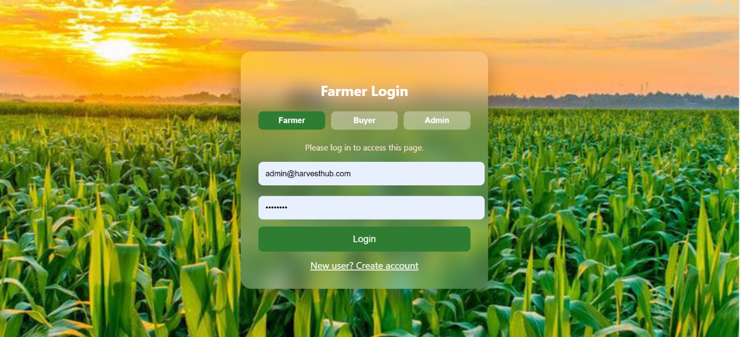
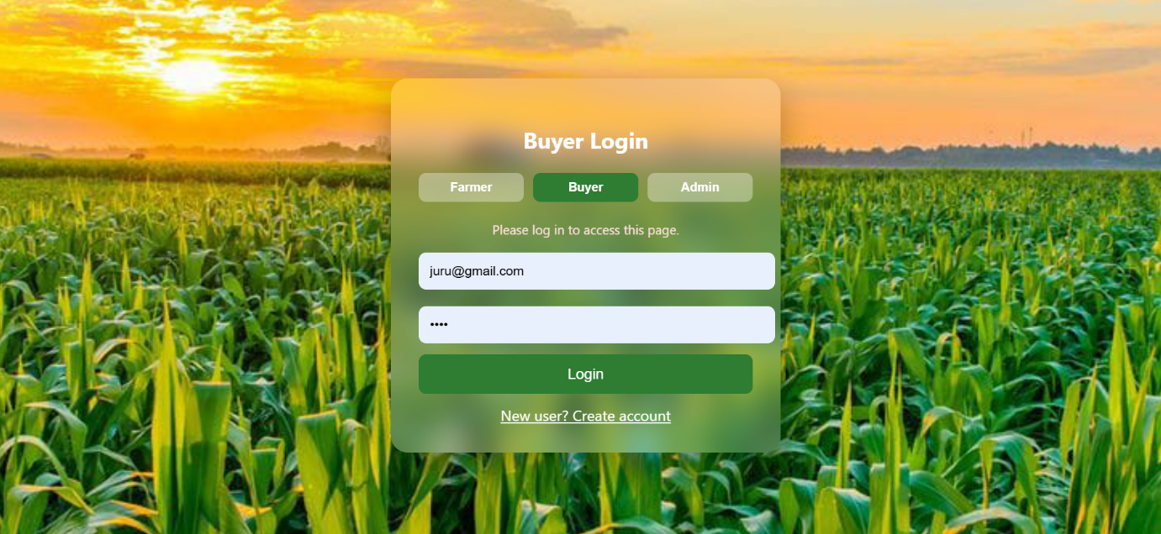
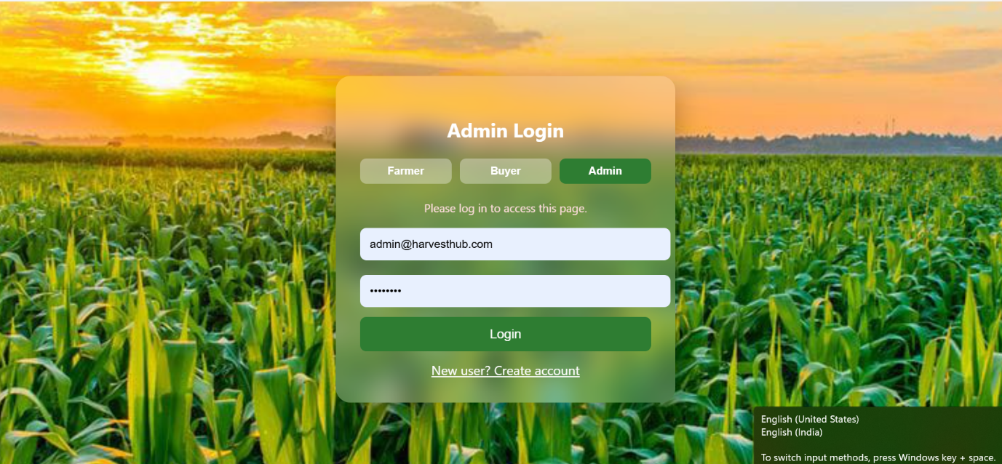
E.SAMPLE OUTPUT
